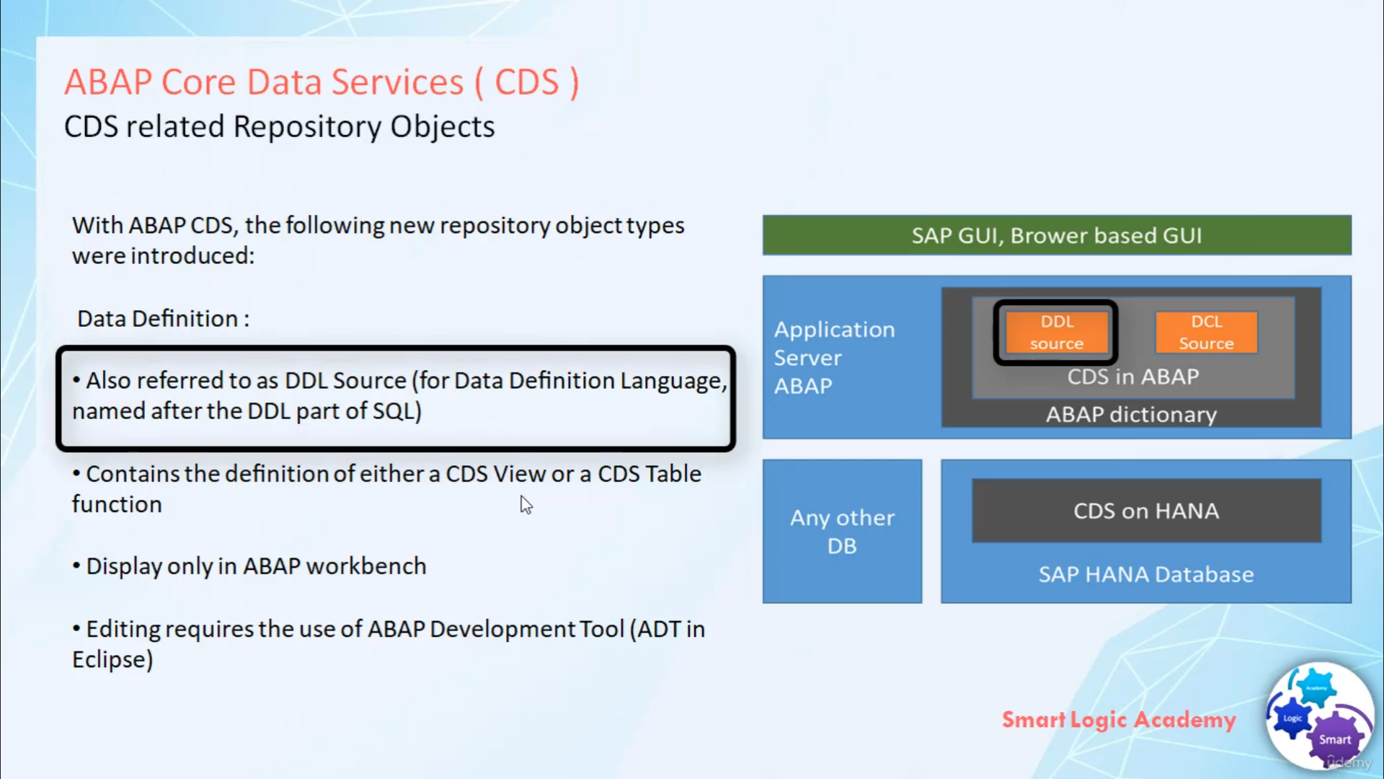

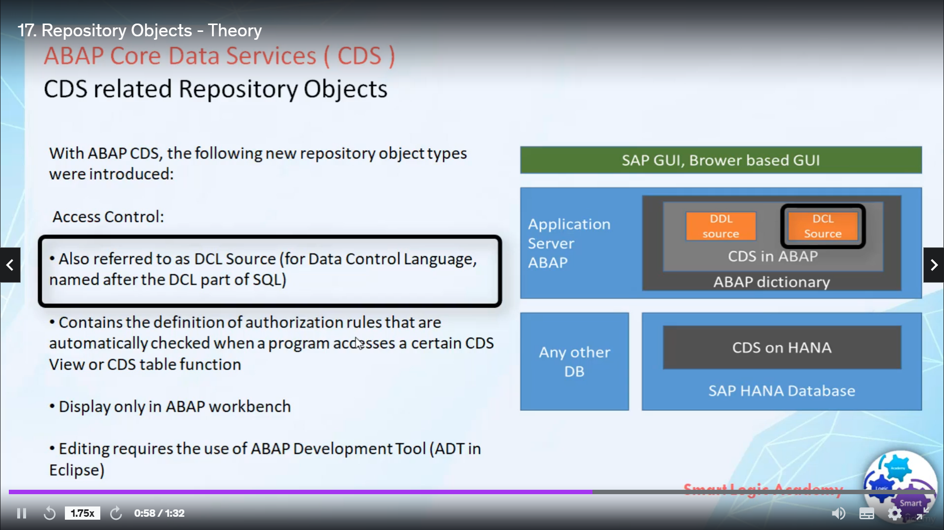

In this video, I will give you complete information about CDS related repository objects. So let's start,

with ABAP CDS two new repository object types were introduced the first one is Data Definition and the second one is Access Control. Data Definition also referred to as DDL SOURCE Data Definition

Language Source.

It contains the definition of CDS view

or CDS Table Function.

These new repository object you can display in ABAP workbench but you can't

edit it in ABAP workbench, for editing new repository object you require special

ECLIPSE based tool called ABAP Development Tool (ADT). Second new repository object is Access Control,

it also referred to as DCL SOURCE Data Control Language source.

It contains the definition of authorization rules that are automatically check when program access a certain

CDS view or CDS Table Function.

Like Data Definition, in ABAP workbench

you can only display Access Control repository object but you can't edit it in ABAP workbench.

For that purpose you require ABAP Development Tool.